CSA1519- CLOUD COMPUTING FOR BIG DATA ANALYTICS
LAB EXPERIMENTS

NAME : P SUDHARSHAN REDDY REG.NO: 192372204

EXP 9: CREATE AVIRTUAL HARD DISK AND ALLOCATE THE STORAGEUSING VM WARE
WORKSTATION.
DATE:
AIM:
To create a virtual hard disk and allocate the storage using vm ware workstation
PROCEDURE:
STEP 1:GOTO VM WARE WORKSTATION.
STEP2: RIGHT CLICK THE VM AND GOTO THE SETTINGS.
STEP 3: ADD HARDWARE WIZARD AND SELECT SCSI AND CLICK NEXT.
STEP 4: CREATE NEW VIRTUAL DISK.
STEP 5: SELCT THE DISK SIZE AS 2.0. AND SELCT SPLIT VIRTUAL DISK INTOMULTIFILES.
STEP 6: GIVE NAME AND CLICK THE FINISH.
IMPLEMENTATION:
STEP 1:GOTO VM WARE WORKSTATION

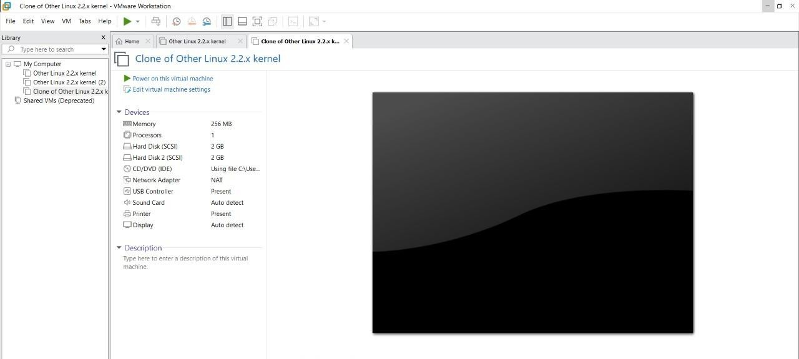

STEP2: RIGHT CLICK THE VM AND GOTO THE SETTINGS
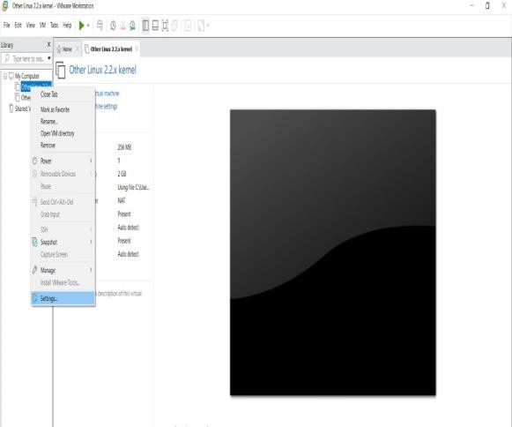

STEP 3: ADD HARDWARE WIZARD AND SELECT SCSI AND CLICK NEXT
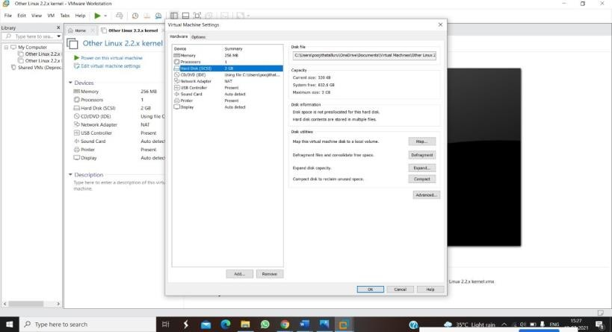
STEP 4: CREATE NEW VIRTUAL DISK
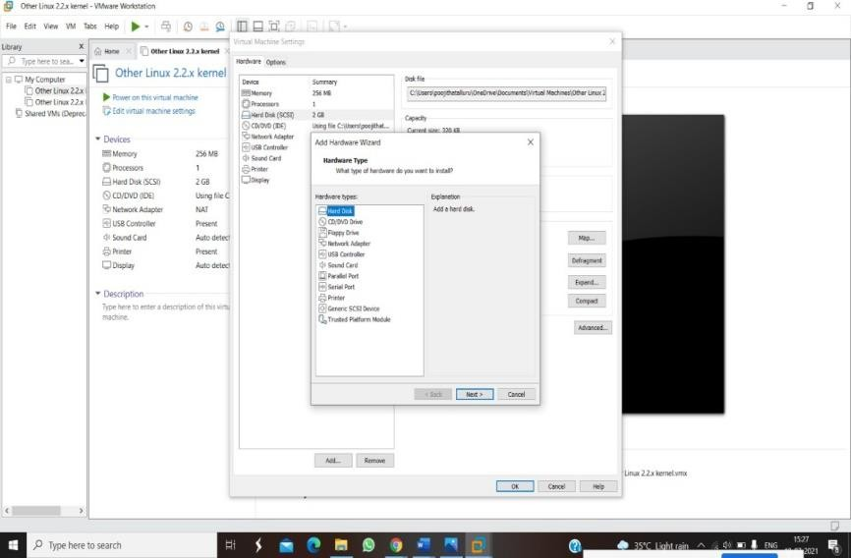
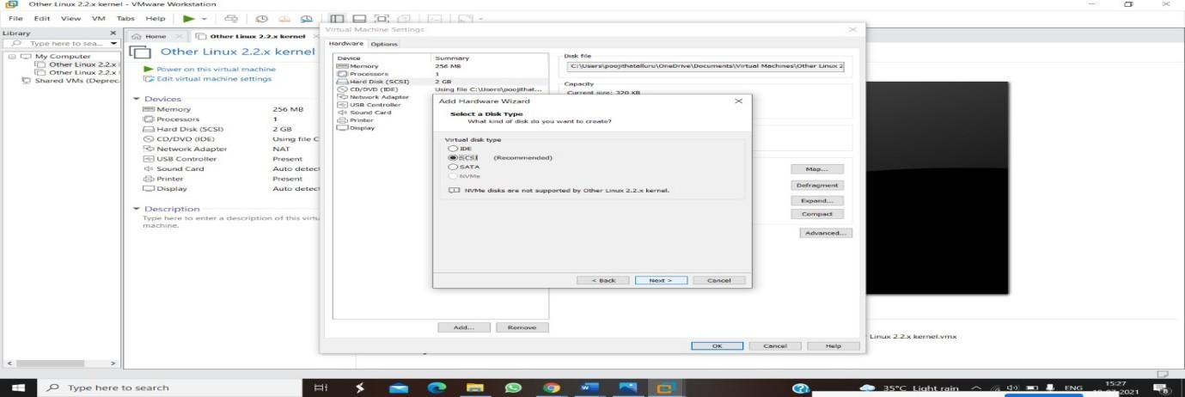
STEP 5: SELCT THE DISK SIZE AS 2.0. AND SELCT SPLIT VIRTUAL DISK INTO MULTIFILES.
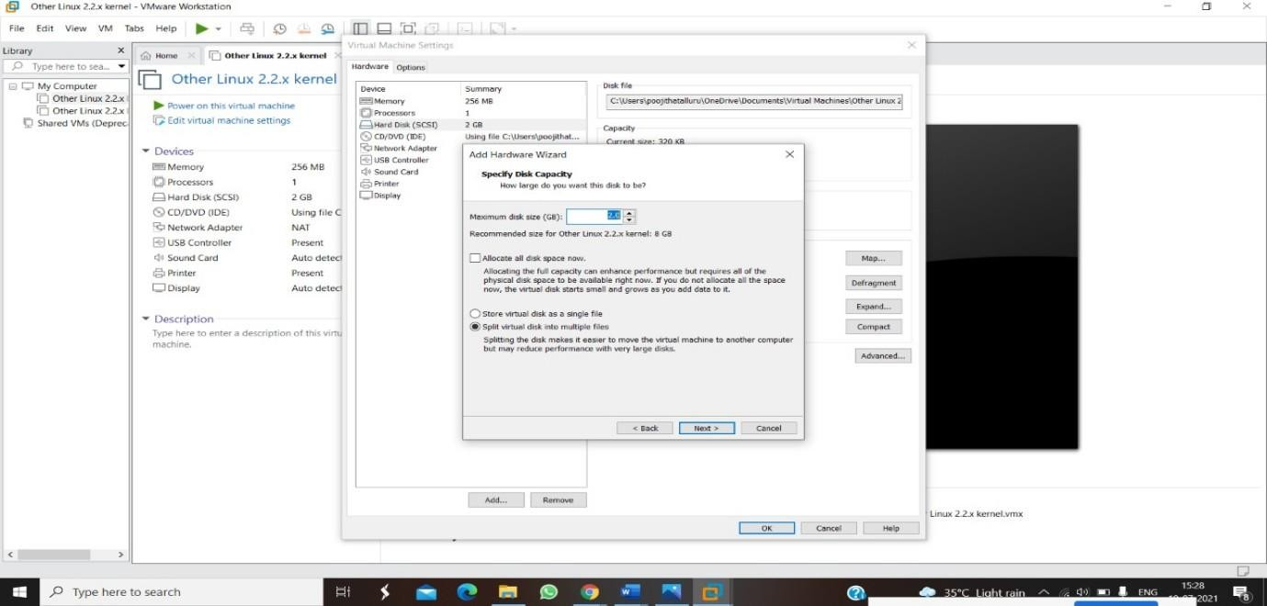
STEP 6: GIVE NAME AND CLICK THE FINISH
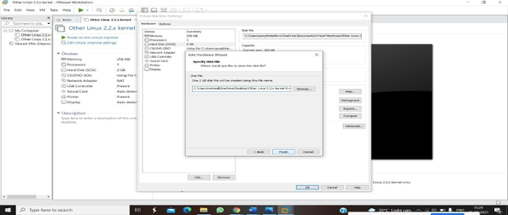

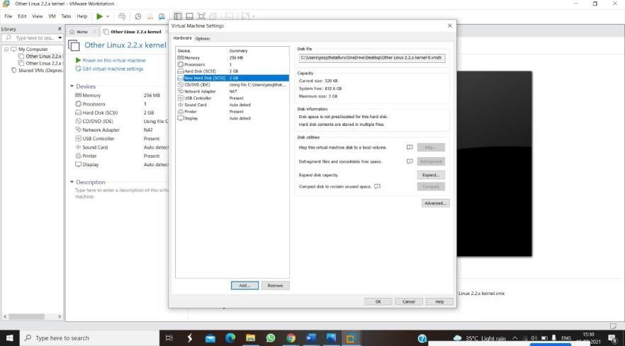

RESULTS:
Successfully AVIRTUAL HARD DISK AND ALLOCATE THE STORAGEUSING VM WARE

